

Quality
Manual

Introduction

What is a quality manual and who needs it?
A quality manual documents the processes, procedures and responsibilities to achieve and guarantee high quality services, samples and data. It describes the implementation, operation and maintenance of the quality management system. Describing all elements of a quality management system allows to have an efficient overview of the biobank operational procedures and helps identifying and addressing potential gaps.
A quality manual can be established both by biobanks and biobank infrastructures, its content will be defined by the type of conducted activities. For the purpose of simplicity, the rest of the document refers to only biobank, even if this template can be adapted to both entities.
This document is intended to be used internally for the biobank personnel as a reference document and externally for auditors, customers and external collaborators.
This quality manual template aims to guide and support biobanks through all stages of their development: from their establishment, through the development of their activities, and towards improving their processes and quality. From the very beginning the biobank can adopt this quality manual and start to complete it. Accordingly, the different chapters can be added following the scheme of the SBP labels, starting with the VITA and its focus on organizational requirements, followed by the NORMA and the documentation of standardized practices and finally reaching the OPTIMA with the global quality aspects of all operational processes (https://swissbiobanking.ch/what-are-the-sbp-labels/ ). A fully completed quality manual furthermore qualifies for the quality management system requirements from the ISO 20387-General requirements for Biobanking.
How to use this quality manual template?
This quality manual template is aimed to be adapted to the scope of your biobank practice and existing documentation. It is not required to have one individual document to address each topic. The biobank may have one document addressing multiple subjects or directly address the subject in detail in the paragraph of the quality manual itself. In the latter case, reference to an external document should be removed.
Words highlighted in pink need to be replaced and detailed where necessary to adapt to your own practice.
This quality manual can be adopted from the establishment of the biobank, only addressing the topics with documents in the VITA label category, notified with the V icon in the listed documents column. With the development of a standardized practice, a biobank could further develop its Quality Manual, by integrating the documents in the NORMA label category, notified with the N icon in the listed documents column. Finally, a completed quality manual encompasses also all the quality optimization related parts part of the OPTIMA label, notified with the O icon in the listed documents column.
To have a complete quality manual, we recommend to address every topics of this template, however if the biobank is not in charge of one process, the template offers a paragraph highlighted in grey, that can be adapted to describe the service provider who is in charge.

Referenced documents are underlined in the text and listed in a table below each paragraph, with a link to our support document embedded in the arrow , accessible by a ctrl- click on it.
The list of documents is set up to be automatically updated in the Appendix section.
This Introduction is not part of the template and should be removed in your version of the quality manual.

1. Introduction 5
1.1. Abbreviations and definitions 5
1.2. Scope 5
1.3. Objectives 6
1.4. References 6
1.4.1. Applicable Law 6
1.4.2. Reference documents and templates 6
1.4.3. Glossary 6
2. Organizational requirements 6
2.1. Governance 6
2.2. Roles and responsibilities 6
2.2.1. Organizational structures 6
2.3. Communication 7
2.3.1. Internal communication 7
2.3.2. External communication 7
3. Quality Requirements 8
3.1. Quality policy and objectives 8
3.2. Management Commitment 8
3.3. Quality plan 8
3.4. Document management 9
3.5. Improvement 10
3.5.1. Internal audits 10
3.5.2. External audits 10
3.6. Risk and Opportunities Management 11
4. Resources requirements 11
4.1. Sustainability 11
4.2. Personnel 11
4.3. Facilities 12
4.3.1. Access and security 12
4.4. Equipment 12
4.4.1. Monitoring of equipment and environmental conditions 13
4.5. IT and data 13
4.5.1. Access rules & security 13
4.5.2. Traceability 13
4.5.3. Data Management 13
4.6. Support services 14
5. Processes requirements 14
5.1. Quality control of sample and data 14
5.1.1. Quality controls 14
5.1.2. Non-conformity management 15
5.1.3. Complaints management 15
5.2. Consent 15
5.3. Collection 16
5.3.1. Safety 16
5.4. Transport and reception 16
5.5. Sample processing 17
5.5.1. Validation of methods 17
5.6. Storage 18
5.7. Transfer of biological material and data 18
5.8. Appendix 20
Appendix 1: Table of reference documents 20

Introduction

Abbreviations and definitions
BIMS Biobank Information Management System
DTUA Data Transfer and Use Agreement
MTA Material Transfer Agreement
QMS Quality Management System
QR Quality Representative
SOP Standard Operating Procedure
SBP Swiss Biobanking Platform
SLA Service Level Agreement

Scope
This Quality Manual describes the Quality Management System (QMS) of the biobank [Name of the biobank] located [Address of the biobank, Zip code, town], Switzerland.
This quality manual aims to define and describe the biobank QMS and all requirements in terms of organization, quality, resource and processes and structure them as described in the scheme below (Figure 1).
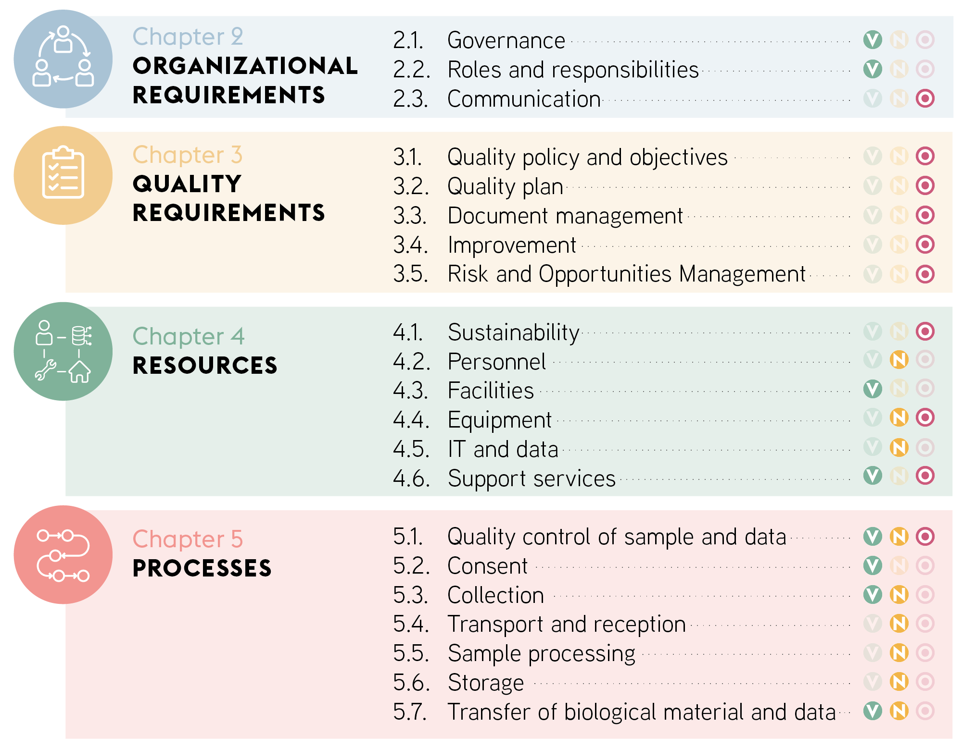
Figure 1: Structural content of the Quality manual, highlighting the hierarchy of organizational requirements applying to all chapters, quality requirements applying to resources and processes and finally the resources required to operate the processes.

Objectives
The aims of the biobank are:
[Describe here the biobank general objectives, e.g. collect and store biological samples from specific disease-population in order to identify disease-specific biomarkers]
The quality objectives are detailed in the Quality Policy and Objectives (part 4.1).

References

Applicable Law
This Quality Manual relies on the applicable legal framework; in particular:
– Federal Act on Research involving Human Beings (Human Research Act, HRA) of 30 September 2011, CC 810.30
– Ordinance on Human Research with the Exception of Clinical Trials (Human Research Ordinance, HRO) of 20 September 2013, CC 810.301
– Federal Act on Data Protection (FADP) of 19 June 1992, CC 235.1
It follows established ethical / professional principles, including the Declaration of Taipei on ethical considerations regarding health-related databases and biobanks (2016).
[List of applicable legal and ethical standards are available on SBP ethical, legal and professional compliance list for human research biobanks applicable in Switzerland]

Reference documents and templates
The list of reference documents and templates is compiled in Appendix 1.

Glossary
Definition of common biobanking terms is available on SBP website: https://swissbiobanking.ch/glossary/

Organizational requirements

Governance
The governance defines how the biobank acts and works and identifies the responsible person(s). It includes the management structures and the rules, set in accordance with the biobank purposes to ensure its compliance with the applicable legal and ethical requirements.
The Biobank Regulation describes the biobank governance by addressing the following points:
- Establishment of the biobank
- Legal status
- Structure
- Consent
- Minors and adults incapable of judgement
- Confidentiality measures
- Access and transfer
- Participant’s right to information
- Finance
- Dissolution of the biobank

DOCUMENT
Biobank Regulation |  | Biobank Regulation | 

Roles and responsibilities

Organizational structures
The responsible person(s) including the operational manager are appointed and assigned with clear functions in the respect of the ethical and legal framework (§21 Taipei, art. 16 ch. 1 CM/Rec(2016)6)).
- The Biobank Regulation describes the organizational structures of the biobank (e.g Strategic Management, Operational Management, Administrative Management, Scientific Committee) and lists the members with their roles and responsibilities.
The list of members and the role of each structure is also described in the Responsibilities SOP.

DOCUMENTS
Biobank Regulation |  | Biobank Regulation
Responsibilities SOP |  | Biobank Responsibilities

Communication

Internal communication
The communication channels within the biobank are the following:
- E-mail: Information regarding daily activities for all biobank personnel takes place via a generic e-mail address: genericaddress@biobank.ch / e-mail to all biobank personnel
- Group meeting: held weekly/monthly/twice a month with all biobank personnel. The objective of this meeting is to review the daily biobanking activities, discuss any issues related to the quality in the daily practice. During this meeting, the biobank operational manger defines a clear agenda and organizes the presentation of new projects and the status of current projects. Each meeting is documented by taking notes of the date of the meeting, the names of attendees, the topics discussed, and the decisions made regarding each item on the agenda including the envisioned next steps.
- One-to-one meeting: regular meetings between the biobank management (responsible person and/or operational manager) and each biobank personnel individually are organized aiming to discuss status of the training, activities, and planning of future activities.
- Management review: meeting held with the responsible person(s), the operational manager and quality representative(s) to review any issues related to quality, ensure the effectiveness of the QMS and discuss improvements. The management review is documented in the Management review report.

DOCUMENTS
Internal communication |  | Internal Communication | 
Management review report |  | Management review

External communication
Human Biobank
External communication with the participants and the public is essential to raise awareness of the biobank activities. Communication is also key to promote trust in the biobank and demonstrates accountability of the biobank towards its participants.
The biobank communicates with the public, with its participants and external stakeholders the following way:
- Communication with participants
Biobank policy regarding participant’s rights to information (right to consult, return of results, right of consent withdrawal and contact information) are described in the Biobank Regulation and Consent documents (detailed in part 5.2).
Non-Human Biobank
The biobank communicates with the public and external stakeholders the following way:

- Public communication
Option a. The biobank communicates relevant information regarding its organization, operational processes and activities via [website, scientific publications, conference presentations, Newsletter, publication of activity reports…]
Option b. The biobank communicates relevant information regarding its organization, operational processes and activities as described in the Biobank Regulation.
- Communication with researchers/biobanks stakeholders
Meetings / Satisfaction surveys with researchers or other services or biobanks receiving samples from the biobank are organized when needed to review ongoing projects, plan new ones and review sample quality and general satisfaction of biobank sample recipients.

DOCUMENT
Biobank Regulation |  | Biobank Regulation

Quality Requirements

Quality policy and objectives
The Quality Policy defines the biobank quality objectives and details specific measures undertaken to meet them. A SMART quality objective is one that is Specific, Measurable, Achievable, Relevant and Time-bound.
The Quality Policy also defines the strategy for planning and reviewing quality objectives. Note that all personnel are aware of the quality objectives and responsible for the quality within the Biobank and for maintaining high-quality standards.

DOCUMENT
Quality Policy |  | Biobank Quality Policy

Management Commitment
The biobank responsible person(s) defines the responsibilities, the quality objectives, allocates the appropriate resources for the development and implementation of the QMS and ensures an efficient communication and understanding of the quality policy.
The biobank management is committed to continuous improvement of the QMS. In particular:
- accountability for the effectiveness of the QMS
- ensuring that the quality policy and objectives are in line with the context and strategic direction of the biobank.
- ensuring that the resources needed for the QMS are available on all levels.
- communication of the importance of effective quality management and of conforming to the QMS requirements
- ensuring that the QMS achieves its intended results.
- fostering improvement of the QMS

Quality plan
The quality plan of the biobank describes the used standards, resources, and processes. Quality planning is involved in a continuous loop of planning, doing, checking, and acting, in turn enabling the continual improvement of the quality management system as summarized in the below figure (Figure 2).

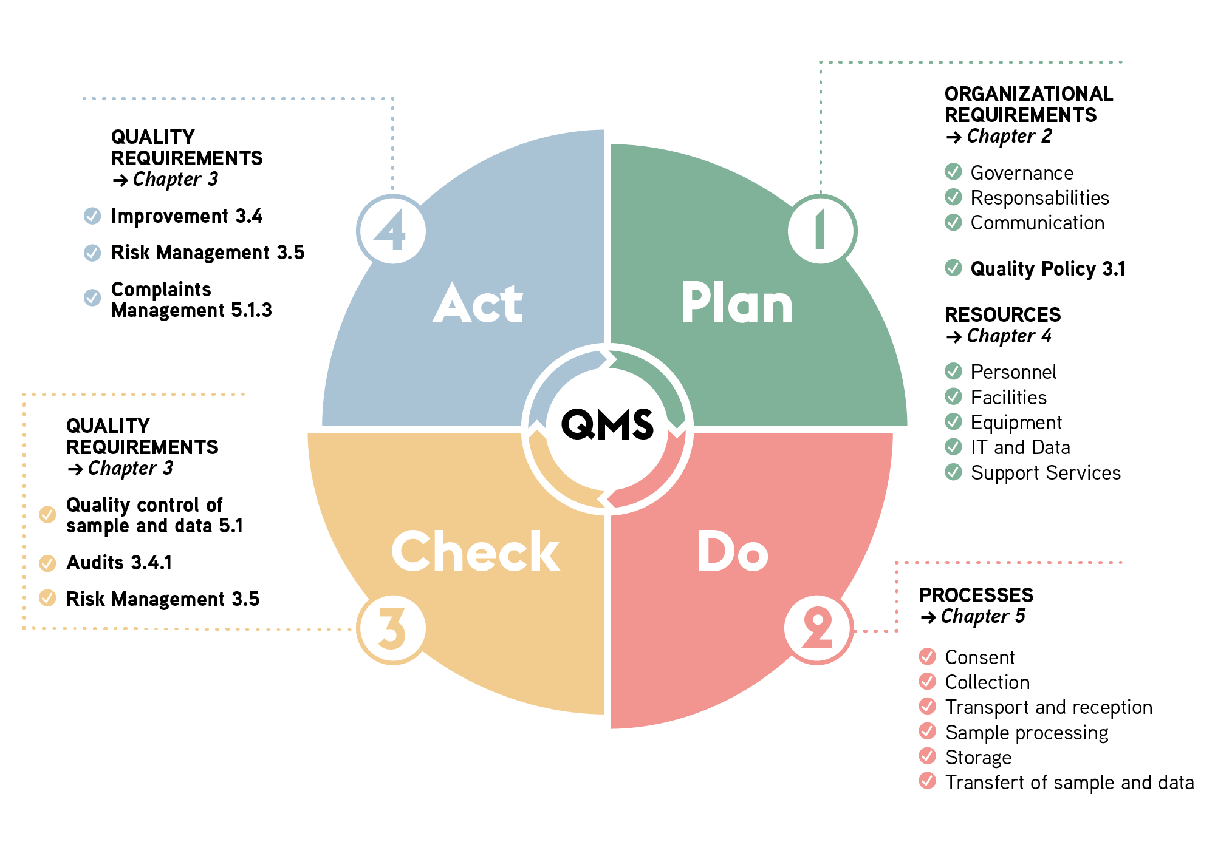

Figure 2: Quality Plan illustrated in the cycle of planning, doing, checking and acting and related chapters of the quality manual to set up, maintain and improve the overall quality system of the biobank.

Document management
The Document Management SOP describes the strategy to develop and maintain a uniform document and record management system with the following objectives:
- Ensure that biobank activities are documented (description of the steps) and recorded in a well-organized, complete, and accurate Document Management System or BIMS
- Harmonize all documents created or modified by the biobank
- Ensure that all documents created and modified by the biobank comply with the current legislation and regulation
- Provide traceability of documents through a history of modifications
- Facilitate education and training of biobank personnel
New procedures and documents are created using a standard template, Standard SOP and Standard document respectively. A list of all the documents is maintained in the List of documents file and in the Document Management System.

DOCUMENTS
Document Management |  | Document Management
Standard SOP |  | Template SOP
Standard Document |  | Standard document
List of documents |  | List of all documents

Improvement
The effectiveness and suitability of the QMS require continual evaluation and improvement, as defined in the Quality Policy and reflected in the quality objectives. The management review is carried out in order to evaluate the biobank activities, the QMS, as well as the corrective and preventive actions if applicable. The analysis and conclusions of the management review are summarized in a Management review report.
As a result, the management review enables continual improvement with the following objectives:
- Ensure that the biobank QMS is continually evaluated and improved.
- Ensure that the biobank operates within legal, ethical, societal, and professional requirements.
- Ensure that the biobank Quality Policy and the quality objectives are always appropriate and suitable via periodical suitability reviews.
- Ensure that the biobank Quality Policy and the quality objectives are communicated with the personnel.
This strategy is detailed in the Improvement Management SOP.

DOCUMENTS
Improvement Management |  | Improvement Management
Management review report |  | Management review

Internal audits
Internal audits are planned and conducted at regular intervals to provide information on whether the QMS is efficiently implemented and maintained. Principles for conducting efficient internal audits are included in the Internal Audits SOP.

DOCUMENT
Internal Audits |  | Internal Audits SOP

External audits
The biobank is evaluated by SBP for its compliance regarding the ethical and legal standards (VITA label) / for process standardization and equipment management (NORMA label) / for optimization of biobanking management system (Optima label). The awarded label(s) are the subject of annual reviews, planned and conducted by SBP.

Description here of other external audits (eg. for other accreditations or certifications)

Risk and Opportunities Management
Risk-based approach is the basis of decision-making in the biobank and is performed at all stages of the biobanking processes, to globally anticipate negative effects, minimize their impact on the biobank operations and guarantee that targeted objectives will be met. Risk assessment includes:
- Identification of threats/hazards that may cause harm to people (biosafety) or issues that may impact quality objectives, biological material and data integrity, IT infrastructure security (data breach, data loss), governance/ethics/regulatory aspects or any related areas.
- Determination of the likeliness that each hazard will occur and how sever the consequences would be.
- Decision about the actions to put in place to stop these hazards from occurring or to mitigate the risk.
- Determination of the risks of damage to their samples and data and establishment of a contingency plan accordingly
- Seize opportunities arising from the taken actions and perform continuous improvement.

DOCUMENT
Risk and opportunities management |  | Risk Management

Resources requirements
The biobank management defines, documents and provides the necessary resources in terms of personnel, facilities, equipment, information system and support services to setup, pursue and improve biobanking activities.

Sustainability
The biobank establishes a Business Model to document its long-term strategy to ensure financial viability.
DOCUMENT
Business Model |  | Biobank Business Model

Personnel
Personnel management procedures follow the Personnel Management SOP and fulfill the following objectives:
- Ensure that the role and the responsibility of all biobank personnel are defined.
- Ensure that the personnel working conditions and tasks are respected by both parties, i.e., employee and employer.
- Ensure that job descriptions, descriptions of roles and responsibilities, as well as training records, are recorded in the Document Management System or BIMS.
- Ensure that personnel is qualified and trained to carry out their assigned tasks.
- Ensure that existing personnel education and training are up-to-date.
The tasks, roles and responsibilities as well as related authorities of all personnel are described in the Personnel File.
The biobank management is responsible for evaluating the needs of new personnel based on the current workload, ongoing projects as well as ensuring available personnel can ensure future developments. New personnel are selected with a profile matching the pre-defined requirements for the new position. The training program for new and current biobank personnel is detailed in the Personnel Management SOP.
Required competencies for each personnel are assessed periodically. Based on these assessments, the biobank management establishes training plan to reinforce necessary competencies and required new ones.

DOCUMENTS
Personnel Management |  | Personnel Management | 
Personnel File |  | Personnel File

Facilities
The biobank facilities include dedicated areas to specific uses for instance office space, sample storage, laboratory, general storage area and lavatories. In particular, activities presenting a contamination risk are isolated from the other activities. The defined dedicated areas are shown on the plan of the biobank facilities below.
Biobank facilities plan or detailed description (type of activities, areas of each defined area, number of rooms, laboratory risk classification)

Access and security
Access to the biobank facilities is secured by key/badge and is restricted to the biobank staff as described in the Biobank Regulation. External collaborators are required to sign a Confidentiality Agreement and to be accompanied by a biobank staff member to enter the biobank facilities.

DOCUMENT
Biobank Regulation |  | Biobank Regulation
Confidentiality agreement |  | Confidentiality Agreement

Equipment
All equipment required to perform biobanking activities is available. Procedures regarding maintenance, calibration, repair and replacement of pieces of equipment are described in the Equipment Management SOP. All maintenances are documented in the Equipment Maintenance Records. Equipment calibration requirement are defined and documented in the Equipment Calibration Records.
A register listing all equipment of the biobank, the Equipment Inventory, is implemented and maintained. Equipment is categorized using a risk-based approach according to their potential impact on quality of sample and data. This approach is further described in the Risk Management part (ch.4.5)

DOCUMENTS
Equipment Management |  | Equipment Management
Equipment Maintenance Records |  | Maintenance records
Equipment Calibration Records |  | Calibration records
Equipment Inventory |  | Equipment Inventory

Monitoring of equipment and environmental conditions
Equipment functions are monitored and registered to ensure proper function. According to risk assessment, environmental variables susceptible to impact sample quality are required to be monitored. Monitoring devices are used to measure the relevant variables (e.g. temperature, humidity, CO2 %) and their acceptance ranges are described in the Equipment Monitoring SOP.

DOCUMENTS
Equipment Monitoring |  | Equipment Monitoring

IT and data

Access rules & security
The biobank uses <BIMS name and version> to document sample-related data, <Name of the system> to document participant-related data and <Name of the system> to manage its documentation. The Data protection SOP describes the access rules to these systems as well as defines the procedures to ensure data security, confidentiality, integrity, and backups to prevent loss or corruption of data. In case of exceptional event the actions described in the contingency plan (part 5.1.2) are followed.

Traceability
The biobank must ensure the traceability of biological material and associated data from collection or reception to transfer or destruction. Especially, traceability is a legal requirement and must be ensured during storage of biological material and data (ethical and legal background: Art 5 HRO, §21 Taipei, art. 16 ch. 4 CM/Rec(2016)6, art. 30 GDPR).
Traceability is guaranteed by:
- Maintaining unambiguous identification of the biological material during all processes including after biological material and/or data transfer
- Linking unambiguously the biological material and associated data
- Keeping track of the location of the biological material
- Using a BIMS to document appropriate sample-related data
- Each operation in the BIMS (addition, modification, deletion) is tracked using program recordings
Measures to guarantee traceability of samples and associated data are described in the Data and Sample Traceability SOP. This procedure also details the requirements in terms of audit trail and data verification process.

DOCUMENTS
Data Protection |  | Data protection
Data and sample traceability |  | Traceability

Data Management
The required data related to the samples and to the participants are described in the Datasets.
The BIMS User Manual describes the usage of the BIMS for the sample-related data entry, the <Participant Data Management system> User Manual details the process of participant-related data entry and data verification is performed as described in the Data and Sample Traceability SOP.
The <Documentation Management system> User Manual explains the usage of the documentation management system.

DOCUMENTS
Datasets |  | Dataset
BIMS User Manual |  | BIMS solution User Manual
Data and sample traceability |  | Traceability

Support services
The biobank determines and monitors the requirements for externally provided services. Services provided by external stakeholders are listed in the Biobank Regulation.
The Service Level Agreement (SLA) details in the form of a written contract the services provided and the expectations between the service provider and the biobank. It describes the scope, the responsibilities, the duration and termination terms of the contract, the quality-related expectations for all services covered by the agreement as well as the extend of services controls and audits.
Records of the service assessment shall be maintained and could be used as part of a regular review of the suppliers and discussed during the management review.

DOCUMENTS
Biobank Regulation |  |  | Biobank Regulation
Service Level Agreement |  |  | Support Services

The biobank also establishes a Business Model to document its long-term strategy to ensure financial viability.
DOCUMENT
Business Model |  | Biobank Business Model

Processes requirements

Quality control of sample and data

Quality controls
Quality control of sample and data is instrumental for each of the biobank processes. The Quality control strategy implementation SOP describes and defines the quality control requirements. The outcomes of quality controls are then documented in Quality Control Results.

DOCUMENTS
Quality control strategy implementation |  | Quality control SOP
Quality control Results |  | Quality control results

Non-conformity management
When any requirement is not met, at any process level, a non-conformity is registered and managed according to the Non-Conformity Management SOP. A non-conformity report is filled in as well as the Non-conformity log. Corrective and preventive actions are proposed to resolve the non-conformity and avoid its recurrence in the future.
Sample acceptance criteria are pre-defined and registered in the Sample acceptance criteria form. In case sample acceptance criteria are not met, a non-conformity must be registered.

DOCUMENTS
Sample acceptance criteria |  | Sample criteria
Non-conformity management |  | Non-conformities SOP
Non-conformity report |  | Non-conformity Report
Non-conformity log |  | Non-conformity log

Complaints management
The Complaint management SOP details how to receive, investigate, treat, record and review complaints received by the biobank from participants, researchers, external stakeholders, or anyone from the public expressing dissatisfaction towards biobank activities.

DOCUMENT
Complaints management |  |  | Complaints management

Consent
Consent process not managed by the biobank:
[Collection, storage and use of biological material are based on a general/specific consent project-specific consent. The consent process is not managed directly by the biobank but by service provider. Consent status and modifications are communicated via e-mail / the BIMS/ other.]

Non-Human biobank without consent requirements can remove this paragraph completely

The type of consent and the eligibility criteria are described in the Biobank Regulation. The biobank follows the Developing Consent Form SOP, describing the requirements for the development or modification of an informed consent.
The process of informing appropriately and obtaining a participant’s consent by qualified personnel is explained in the Obtaining Consent SOP. Provisions for consent withdrawal are also included in this SOP.

In case samples and data are kept in a coded form: Once enrolled, participants are registered in the Participant Identification log. This log must remain strictly confidential under the responsibility of the key keeper, who should be independent of the research project and clearly identified in the Biobank Regulation.

DOCUMENTS
Biobank Regulation |  | Biobank Regulation
Specific / General consent |  | Consent Information  Consent Form
Developing Consent Form |  | Developing consent
Obtaining Consent |  | Obtaining consent
Participant Identification Log |  | Participant Log

Collection
Collection process not managed by the biobank:
Biological material is collected within clinical settings in the service provider by trained nurses or clinicians. Collection-related information are registered in the Sample tracking form and the BIMS/Database.

Biological material collection is performed by appointed and trained personnel according to the Biological Material Management SOP. Collection-related information are registered in the Sample tracking form and the BIMS/Database.

DOCUMENTS
Biological Material Management |  | Biological Material Management
Sample Tracking Form |  | Sample Tracking Form

Safety
The Safety SOP addresses the safety measures to undertake in case a serious event occurs to a participant during biological material collection.

DOCUMENTS
Safety |  | Safety SOP

Transport and reception
Transport not managed by the biobank
Transport of biological material is ensured by service provider, by trained personnel according to their standard procedures / our instructions. Transport and reception information are registered in the Sample tracking form and in the BIMS/Database

To ensure the integrity and quality of the biological material received at the biobank, the personnel follow the Biological Material Management SOP, describing the transport and reception processes. The transport and reception related information are documented in the Sample tracking form and in the BIMS/Database.

DOCUMENTS
Biological Material Management |  | Biological Material Management
Sample Tracking Form |  | Sample Tracking Form

Sample processing
Sample Processing not managed by the biobank:
Samples are processed by service provider by trained personnel according to their standard procedures / our biobank work instruction. Documentation of the processing date time and resulting aliquots are described in the Sample tracking Form and in the BIMS/Database

Processing of samples is performed according to the Biological Material Management SOP and the appropriate work instructions as listed in the table below. The validated processing methods are listed in the Methods list. In parallel, to be sure only appropriate and valid consumables are used during the processing, a list of used consumables and their expiration date is maintained in the Expiring consumables Inventory. Processing date and time and resulting aliquots are described in the Sample tracking From and in the BIMS.

DOCUMENTS
Biological Material Management |  | Biological Material Management
Processing Work Instruction |  | Tissue Preparation Work instruction  Blood Processing Work instruction
Methods List |  | Methods
Expiring Consumables Inventory |  | Expiring consumables inventory
Sample Tracking Form |  | Sample Tracking Form

Validation of methods
Method validation is required for new or modified methods used in the biobank. When standardized methods are not available, the Validation Methods SOP is followed. Results of the method validation are registered in the Method validation record. A Method list is kept up to date with the dates of the method validation.

DOCUMENTS
Validation of Methods |  | Validation of Methods
Method Validation Record |  | Methods validation record
Methods List |  | Methods

Storage
Storage Process not managed by the biobank:
Samples are stored by service provider by trained personnel according to their standard procedures / our biobank work instruction. The storage related data are also registered in the Sample tracking form and is tracked in the BIMS / Database.

Biological material storage is performed as described in the Biological Material Management SOP. The storage related data are also registered in the Sample tracking form and is tracked in the BIMS /Database.

DOCUMENTS
Biological Material Management |  | Biological Material Management
Sample Tracking Form |  | Sample Tracking Form

Transfer of biological material and data
Transfer of biological material and data not performed nor planned
Data and biological material are reserved for biobank collaborators only and are not transferred.
Transfer of biological material and data not managed by the biobank
Data and biological material are transferred by service provider according to their standard procedures. Transfer requests are transmitted by e-mail and the confirmation of biological material shipment by service provider is given by e-mail and entered in the BIMS/Database.

Access rules for biological material and data transfer are described in the Biobank Regulation. The MTA (and/or DTUA) governs the transfer of biological material and associated data that are made available by the biobank to a recipient wishing to use these resources for its own research purpose. For each new partner, receiving biological material and/or data from the biobank, an MTA must be signed by the two legal entities.
Samples are prepared and transferred as described in the Biological Material Management SOP. The Shipping Log is filled in to register the shipment related information. The information in the BIMS / database is updated accordingly.

DOCUMENTS
Biobank Regulation |  | Biobank Regulation
MTA |  | MTA
Biological Material Management |  | Biological Material Management
Shipping Log |  | Shipping Log

Revision History
Version | Effective Date | Revision Details
1.0 |  | Initial release

Appendix
SBP templates are accessible in SBP website: https://swissbiobanking.ch/documents-list/
The Document names will be updated automatically base on the tables of the document. Select all text (Ctrl A) and type F9 to update. The column with SBP support documents is only there as an aid and can be removed to finalize the document..

Appendix 1: Table of reference documents
DOCUMENT SUBJECT | DOCUMENT | SBP SUPPORT DOCUMENT
Biobank Regulation | Biobank Regulation | SBP Biobank Regulation template
Responsibilities SOP | Biobank Responsibilities | 2.01.001 - SOP – Responsibilities
Internal communication |  | Not available
  Internal Communication
Quality Policy | Biobank Quality Policy | 2.04.004 Quality Policy
Document Management | Document Management | 1.04.001 - SOP - Document Management
Standard SOP |  | 2.04.001 Standard SOP
  Template SOP
Standard Document |  | 2.04.002 Standard document
  Standard document
List of documents |  | 2.04.003 List of essential documents
  List of all documents
Improvement Management |  | 1.04.003 - SOP - Improvement Management
  Improvement Management
Management review |  | 2.04.005 - Management review report
  Management review
Internal Audits |  | 1.04.004 - SOP - Internal Audits
  Internal Audits SOP
Risk and opportunities management |  | 1.04.006 – SOP – Risk management
  Risk Management
Business Model |  | Not available
  Biobank Business Model
Personnel Management |  | 1.02.001 - SOP - Personnel Management
  Personnel Management
Confidentiality Agreement |  | Not available
  Confidentiality Agreement
Personnel File |  | 2.02.001 Personnel File
  Personnel File
Equipment Management |  | 1.02.002 - SOP - Equipment Management
  Equipment Management
Equipment Maintenance Records |  | 2.02.003 Equipment Maintenance Records
  Maintenance records
Equipment Calibration Records |  | 2.02.002 Equipment Calibration Records
  Calibration records
Equipment Inventory |  | 2.02.004 Equipment Inventory
  Equipment Inventory
Equipment Monitoring |  | Not available
  Equipment Monitoring
Data Protection |  | 1.02.004 - SOP - Data Protection
  Data protection
Data and sample traceability | Traceability | 1.02.003 - SOP - Data and Sample Traceability
Datasets |  | Data Dictionary Tissue  Data Dictionary Liquid
  Dataset
BIMS User Manual |  | Not available
  BIMS solution User Manual
Service Level Agreements |  | Service Level Agreement Template
  Support Services
Quality control strategy implementation |  | 1.04.005 - SOP - Quality control strategy implementation
  Quality control SOP
Quality control Results |  | 2.04.009 Quality Control Results
  Quality control results
Sample acceptance criteria |  | 2.03.003 Sample Acceptance Criteria
  Sample criteria
Non-conformity management |  | 1.04.002 - SOP - Non-Conformity Management
  Non-conformities SOP
Non-conformity report |  | 2.04.007 Non-conformity Report
  Non-conformity Report
Non-conformity log |  | 2.04.008 Non-conformity log
  Non-conformity log
Specific / General consent |  | Not available
  Consent Information
  Consent Form
Developing Consent Form |  | 1.01.01- SOP - Developing Consent Form
  Developing consent
Obtaining Consent |  | 1.01.02- SOP - Obtaining Consent
  Obtaining consent
Participant Identification Log |  | 2.02.006 Participant Identification log
  Participant Log
Biological Material Management | Biological Material Management | 1.03.001 - SOP - Biological Material Management
Sample Tracking Form | Sample Tracking Form | 2.03.001 Sample tracking form
Safety |  | 1.01.003 - SOP - Safety & Complaint
  Safety SOP
Complaints management |  | 1.01.003 - SOP - Safety & Complaint
  Complaints management
Processing Work Instruction | Tissue Preparation Work instruction  Blood Processing Work instruction | Not Available
Methods List |  | 2.03.005 Methods list
  Methods
Expiring Consumables Inventory |  | 2.02.005 Expiring Consumables Inventory
  Expiring consumables inventory
Validation of Methods |  | 1.03.002 - SOP - Validation of Methods
  Validation of Methods
Method validation record |  | 2.03.004 Method validation record
  Methods validation record
MTA | MTA | SBP MTA 2.0
Shipping Log |  | 2.03.002 Shipping Log
  Shipping Log

Process : Any activity (e.g. sample processing) or set of activities that uses resources to transform inputs (e.g. collected samples) into outputs (e.g. ready-to-use samples).
Procedure : An uniform method that outlines how to perform a process.
Quality Management System: The set of measures put in place by the biobank to achieve its objectives
Biobank : An organized entity with a governance in place responsible for the management of biological resources
Biobank infrastructure: An organized facility that offers services to biobanks

