SOP
DATA QUALITY

Document number 1.02.004
Version 1.0
Category Resource Management
Sub-category IT

Authored by Swiss Biobanking Platform
Effective date

TABLE OF CONTENT
A1. SCOPE 2
A2. OBJECTIVES 2
A3. ABBREVIATIONS AND DEFINITIONS 2
B. Personnel Management 3
B1. ROLES AND RESPONSIBILITIES 3
C. Process Management 4
C1. DATA MANAGEMENT PLAN 5
C2. DATA INTEGRITY 5
C3. DATA PRIVACY 6
C4. DATA SECURITY 6
C5. DATA PROTECTION 7
C6. DATA QUALITY CONTROL 7
C7. TRAINING AND COMMUNICATION 8
D. RESOURCES MANAGEMENT (OPTIONAL) 8
D1. MATERIALS AND EQUIPMENT 8
D2. POTENTIAL HAZARDS AND PRECAUTIONS TO TAKE 8
D3. PROTECTIVE WEAR AND SAFETY EQUIPMENT 8
E. REFERENCES 9
E1. REFERENCE TO LAWS, REGULATIONS, AND GUIDELINES AND OTHER SBP DOCUMENTS 9
E2. APPENDICES 9
E3. REVISION HISTORY 9

GENERAL INFORMATION

SCOPE
SBP SOPs are based on Good Biobanking Practices and should serve as reference guidance for biobanks to develop site-specific Work Instructions. In particular, this SOP applies to the biobank personnel involved in data management (e.g. biobank operational manager, data manager) and provides insights and guidance towards the implementation of a data quality strategy in the biobank, including:
- The data life cycle and how the biobank manages data in its whole workflow.
- The measures implemented to guarantee data integrity as well as privacy, security and protection. This includes measures to prevent data loss, misuse, and damage.
- The measures implemented to guarantee data quality.
- The personnel training to ensure the measures are adequately implemented/performed.
- The communication related to the data quality.
When applicable, biobanks are responsible and accountable for guaranteeing the privacy of the participants and safeguarding the confidentiality of the associated data stored in the Biobank.

OBJECTIVES
- Ensure the integrity, privacy, security and protection of samples and associated data by proposing adequate measures fulfilling the legal requirements [1] [2].
- Enhance data quality by applying quality management tools such as risk management, quality control, non-conformities, and improvement management.
- Raise personnel awareness about the risks related to data integrity, privacy, security, and protection.
- Develop a Data Management Plan that documents the strategy including the measures developed by the biobank related to the handled data (see Annex 1).

ABBREVIATIONS AND DEFINITIONS
When appropriate, a list of definitions and abbreviations should be included for the terms used in the SOP.
For this document, the following definitions apply:
- ALCOA principles = Acronym including the set of characteristics to be met to reach data integrity (Attributable, Legible, Contemporaneous, Original, Accurate):
- Attributable data = The identity of the person or computer system that collected or generated the data, as well as the date, time and place of origin are recorded in an understandable way.
- Legible data = Data should be readable. Handwritten data must be easy to read and recorded in a permanent medium. Signatures should be identifiable. Electronic data should be recorded on a durable support using consistent language and format that can be read by different computing systems.
- Contemporaneous data = Data should be documented at the time the action takes place.
- Original data = Data must match their original version when copied. Original records and copies must be distinguished.
- Accurate data = Data entered into the system must be correct and truly represent the facts. When a data needs to be corrected, previous versions are recorded, and verification of the correctness is performed.
- ALCOA+ principles = ALCOA principles including additional implicit characteristics (Complete, Consistent, Enduring, Available).
- Complete data = Data must be comprehensive. An incomplete field could lead to a biased interpretation.
- Consistent data = Data must be free of errors or inconsistencies and must allow the sequence of events to be easily deduced.
- Enduring data = Data should be available for a pre-defined duration after it is recorded .
- Available data = Data must be easily accessible.
- Analytical data = Data related to the use of biological material (e.g: test result, used kit, testing method according to LOINC/SNOMED CT nomenclatures, testing instrument, bioinformatics pipeline).
- Pre-analytical data = Data related to the phase before a test result is obtained. It may include data related to collection, processing and storage of biological material (e.g. collection time, transport temperature, centrifugation speed, storing temperature, etc.).
- Post-analytical data = Data related to the phase after a test result is obtained (e.g: result report, post-process Quality Control, freeze-thaw cycle details).
- Anonymization = The irreversible removal of the link between the biological material and/or associated data and the participant, so that no specific participant can be reidentified.
- Associated data = Personal, analytical, preanalytical and/or postanalytical data.
- BIMS = Biobank Information Management System.
- Coding = The reversible removal of the link between the biological material and/or associated data and the participant, so that a specific participant can only be reidentified through a key.
- Data integrity = Assurance of data validity over its whole life cycle, based on the ALCOA+ principles.
- Data Management Plan = Document showing how data handling is planned and managed on the whole data life cycle.
- Data security = refers to the measures taken to keep the data safe from unauthorised access and distribution.
- Data privacy = refers to the measures taken to protect confidentiality of the data and all the processes related to sharing the data with third parties (data governance).
- Data protection = refers to the measures taken to restore the data in the event of a loss or corruption.
- Data quality = refers to the measures and quality management tools applied to the data to guarantee they are fit-for-purpose. Data quality focuses on data integrity, security, privacy and protection as a whole.
- Encryption = Converting data from a readable into an encoded format, unusable without a specific decryption key with the aim to prevent unauthorized access.
- Health-related data = Information concerning the health or disease of a specific or identifiable person, including genetic data.
- MDTUA = Material and Data Transfer and Use Agreement.
- Metadata = Data that provides information about other data (e.g. data provenance, data collection time).
- Personal data = All information relating to an identified or identifiable person, including health-related data.
- QR = Quality representative.
- SBP = Swiss Biobanking Platform.
- SOP = Standard Operating Procedure.
- Structured data = Electronic data formatted with a pre-defined structure and format, based on a model (e.g. pre-analytical data recorded in a BIMS, based on SBP datasets). Structured data are the basis of interoperability (e.g. following certain formats such as LOINC, SNOMED CT or RDF).
- Unstructured data = Electronic data in its native format (e.g. images, video, free text, physician note on medical file).

Personnel Management

ROLES AND RESPONSIBILITIES
BB personnel | Responsibility / role
BB Manager/Director | - Prepares the Data Management Plan.  - Plans the risk assessment and analysis regarding data integrity, privacy, security, and protection A.  - Appoints a Key-keeper.  - Proposes confidentiality agreements.  - Authorises personnel to access the database (e.g: BIMS).  - Defines backup and recovery plans or identifies the contact IT department to get information.  - Implements […] measures.
Key-keeper | - Keeps the key to coded data.  - Protects the key from disclosure (unless authorized by law).
Qualified personnel / Quality Representative | - Coordinates the risk assessment related to data integrity as well as data privacy, security, and protection A.  - Trains personnel on data quality management and related risks.  - If authorized, accesses the database (e.g.: BIMS) and enters data associated to samples.  - Schedules, initiates and performs the Quality Control process (data and sample verification) B.  - Records data and sample verification outcomes and verifies that other Quality Controls are documented B.  - Records non-Conformities C.  - Provides quality reports about the biobank.
IT personnel | - Participates to the risk assessment and analysis regarding data integrity as well as data privacy, security, and protection A.  - Implements and administers the backup system.  - Recovers data, when necessary.  - Authorises personnel to access the database.  - Implements […] measures.

Process Management

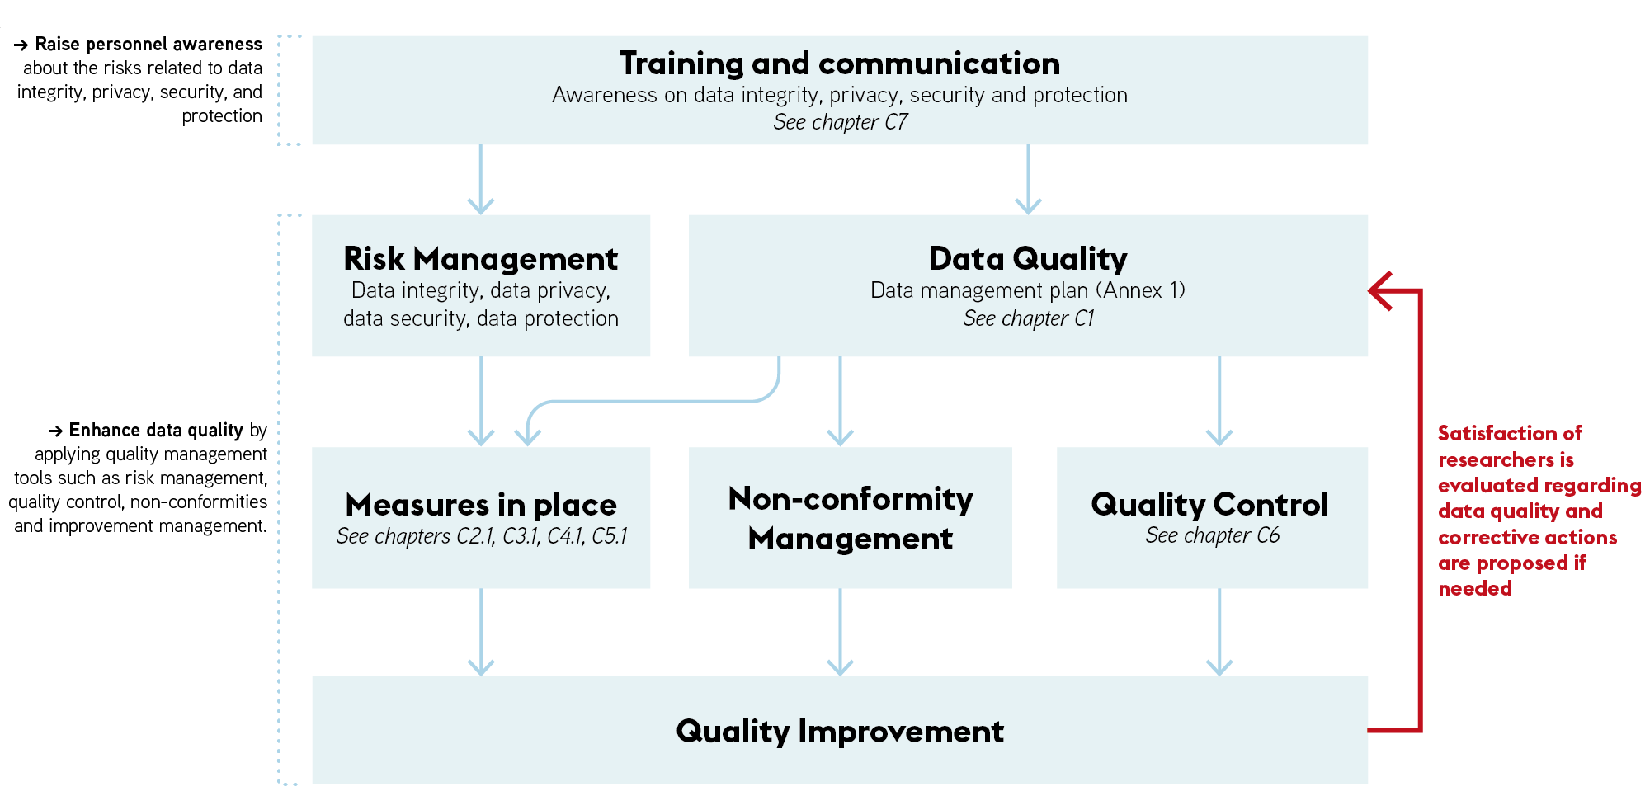

DATA MANAGEMENT PLAN
- A Data Management Plan is developed to document how the data are managed by the biobank (see Annex 1). It describes the type, format, source, structuring, metadata availability, sensitivity, related variables, producer, ownership, storage location, encryption/coding, access, storage duration, final use, and possible transfer of data handled by the biobank.
- A risk-based approach is conducted to evaluate the hazards related to the integrity, privacy, security, and protection of the data throughout all the phases by which data are created, recorded, processed, transmitted, reviewed, reported, archived and retrieved ^{A}. In particular, risks related to the confidentiality (e.g.: participant re-identification after coding) and impartiality should be carefully evaluated [4].
- Adequate risk control, including actions to mitigate the risks are proposed ^{A}.
- Adequate risk monitoring is implemented ^{A}. Based on the evaluation of efficacy, actions are implemented on a long-term basis.
- Routine organizational and technical measures implemented to guarantee data integrity, as well as data privacy, security and protection are described in the present document.
- A Material and Data Transfer and Use Agreement (MDTUA) governs the transfer and use of human biological material and associated data ^{D}. This aspect is described in the biobank regulation.

DATA INTEGRITY
- Electronic as well as paper-based data entries are accurate to ensure the quality of the data and their usage in downstream applications. The use of a BIMS will help in the process of entering data, checking quality (consistency, completeness, and correctness) and export.
- To that purpose, the biobank implements measures to guarantee data integrity of source documentation related to the biological material at each step of its life cycle. Data meet the ALCOA principles: be Attributable, Legible, Contemporaneous, Original and Accurate. Implicit in the ALCOA principles, data records should also be complete, consistent, enduring and available (ALCOA+).

Description of the implemented measures for data integrity
[Attributable data]
- Electronic based: [Audit trail; Electronic data access rules; Data access tracking …]
- Paper-based: [Data as well as corrections are dated and signed; …]
[Legible data]
- Electronic: [Access control; Readable and identifiable electronic format; …]
- Paper-based: [Signatures are identifiable; Ink used for biological material labels is resistant to common laboratory solvent and water and very low temperature when needed; consistent language determined with dataset list added by hand or printed on the labels; labels resistant to storage temperatures (cryolabels); …]
[Contemporaneous data]
- Electronic based: [Automatic time and data stamps; …]
- Paper-based: [If an observation is documented later, it is documented as such, …]
[Original data]
- Electronic-based: [Data archiving function; Version control; …]
- Paper-based: [Original version archiving; Version control; …]
[Accurate data]
- Electronic based: [Standardized data entry; Validation of computerized system methods E; Safeguard features or automated edit checks; Version control…]
- Paper-based: [Standardized data entry; Independent double check of the handwritten data; Version control…]
[Complete data]
- Electronic based: [Data and sample verification; …]
- Paper-based: [Independent double check of the handwritten data; Data and sample verification; …]
[Consistent data]
- Electronic based: [Single source of data; …]
- Paper-based: [Copy of the data is identified as such; …]
[Enduring data]
- Electronic based: [Backup system and recovery plan; data protection concept…]
- Paper-based: [Documents archive; …]
[Available data]
- Electronic based: [Centralized source of data; …]
- Paper-based: [Version control; …]

DATA PRIVACY

Description of the implemented measures for data privacy
[Coding]
- Coding is performed during the [consent, collection, reception] process by [personnel from the biobank, personnel from the institution]. The original clinical data are stored in [name of the database or server] [in an encrypted form] under the responsibility of [the biobank, the data science center].
- In the presence of coded data, a Participant Identification Log is filled out for each participant F. Since this document allows the coding/decoding of participant’s biological resources, it is kept confidential. This document is stored in [name of the database or server] [in an encrypted form] under the responsibility of [the biobank, the data science center].
- A key-keeper is appointed by the biobank Manager/Director to access and manage the Participant Identification Log F. The appointed key-keeper is not involved in the research project based on the coded data of which he/she has the key, according to the Human Research Ordinance (HRO) of 20 September 2013, 2013 Art. 26 [2].
- The decoding of human participant’s biological resources follows the Human Research Ordinance (HRO) of 20 September 2013, Art. 27 [2].
[Anonymization]
- When data are anonymized, qualified personnel ensures that the personal data are irreversibly masked or deleted, in agreement with the Human Research Ordinance (HRO) of 20 September 2013 Art. 25 [2], according to the following process:
- [Describe the procedure that is used to anonymize the data]
[De-identification]
- De-identification process is performed [at the end of coding/ anonymization process, before transferring the data to the researchers].
[Data destruction policy]
- Description on the destruction of personal data is documented: [Describe the procedure that is used to destroy personal data].

DATA SECURITY

Description of the implemented measures for data security
Location of the data handled by the biobank is described in Annex 1.
Physical access rules
- The access to the premises where data can be accessed is granted to the personnel who are authorised to enter, audit, access, and process the data stored, according to the tasks described in the Personnel file G, H. Authentication/access occurs via [badge system, access code, alarm system].
- When appropriate, the BB Manager/Director proposes a confidentiality agreement to guests, visitors, outsourced employees, auditors/inspectors, and newly authorised/employed personnel.
Workstations
[Printed documents and sensitive objects (flash drives, CD-ROMs, etc.) are locked in specific drawers; virus scanner is installed on each computer and updated regularly.]
Electronic data access rules from inside the organization
[Database 1 :…]
- The access to the database is granted to the personnel who are authorised to enter, audit, access, and process data stored in the database, according to the tasks described in the Personnel file G, H. [Users have different user accounts for the different applications accessed on the same session].
- Accounts are unique and personal. Shared accounts or access to the database with another user’s account are forbidden [Login is secured via 2 factor identification; firewall installed on computers].
- IT personnel implements IT safety measures to prevent and detect security breaches of the database.
- Electronic data access can be monitored, audited, and documented [Access logs are recorded and archived].
- The use of “strong” (or non-intuitive) passwords is required to access the database. [A strong password consists of at least eight characters, including upper- and lower- case letters, digits, and special characters].
- The personnel log off from the database when switching off their computers and when moving from workplace.
- The passwords allowing access to data is kept confidential. Personnel do not share with anyone nor write down the password.
- The personnel change the passwords on a regular basis [frequency].
- If an account or a password is suspected to have been compromised, the password is immediately changed, or the account are blocked. A non-conformity is recorded, and corrective actions proposed C.
Electronic access rules from outside the organization
- Access is secured for personnel accessing data from outside the organization [login is secured via 2 factor identification; firewall installed on computers].
- Electronic data access should be monitored, audited, and documented [Access logs are recorded and archived].
[Database 2 :…]

DATA PROTECTION

Description of the implemented measures for data protection
Backup system and recovery plan
- The BB Manager/Director is aware of the Data Protection Policy in her/his institution. A backup routine and recovery plan should be in place to protect data against misuse, loss, and damage.
- The backup is performed automatically and on a regular basis. The frequency of the backups is defined by the BB Work Instructions and depends on the frequency of data entry modifications.
- In case of user error, failure of equipment, catastrophic event, or deliberate intrusion or hacking, the personnel is aware of the immediate actions to implement (e.g., contact with IT service, disconnect affected workstations, communicate with personnel, changing password, …). A non-conformity is recorded and corrective actions proposed C.

DATA QUALITY CONTROL

General data quality control
- QR verifies and documents that Adequate Quality controls are performed and documented according to the SOP for quality control strategy.
- QR controls that the activities related to data quality have been performed according to a defined schedule.
- QR controls that the personnel which are handling data and are authorised to access the database, are qualified and trained, according to the job descriptions H.
- QR controls that the appointed key-keeper is not involved in the research project based on the coded data of which he/she has the key.
- QR controls that the backup is up to date so that the database can be entirely and accurately recovered.
- Every time the QR performs quality controls on the process outputs, quality control details (date of QC, outcomes) are to be recorded ^{I}.

Data verification quality control
- Data verification is a quality control measure that is carried out periodically to confirm the integrity of the associated data B.
- The QR defines the frequency of the data verifications.
- The QR schedules the date of the data verification and initiates the data verification.
- The laboratory personnel carry out the data verification by selecting associated data on a random basis. The laboratory personnel controls if the associated data are complete, correct, and corresponding to the right sample. If the data are corrupted, missing, or incorrect, the laboratory personnel immediately modify the information recorded in the BB database or BIMS to reflect the actual situation. A non-conformity is recorded C or the sample is flagged in the BIMS.
- The acceptance range for a successful data verification is defined.
- Data verification outcomes are documented and recorded in the BIMS or on paper B.

Sample verification quality control
- The sample verification is a quality control measure that is carried out periodically to confirm that the appropriate biological material is in the correct location as indicated by the BB database or BIMS B.
- The QR defines the frequency of the sample verifications.
- The QR schedules the date of the sample verification and initiates the sample verification.
- The laboratory personnel conduct the sample verification by selecting samples on a random basis. The laboratory personnel controls if the label attached to the sample matches the information recorded in the BB database or BIMS. If the sample label is missing or is incomplete or does not match the recorded inventory, the Laboratory personnel immediately modifies the information recorded in the Document Management System or BIMS to reflect the actual situation. A non-conformity is recorded ^{C}.
- The acceptance range for a successful sample verification is defined.
- The laboratory personnel ensures that the sample temperature is maintained constant during the sample verification and minimises the time that the samples are removed from the storage to prevent the sample damage.
- Sample verification outcomes are documented and recorded in the BIMS or on paper B.

TRAINING AND COMMUNICATION
- Identify in your data governance the roles and responsibilities as well as the liability issues with regards to data handling. These aspects are documented in the Biobank Regulation.
- Personnel training and communication are key to guarantee data integrity as well as data privacy, security and protection.
- Specific personnel training regarding data integrity as well as data privacy, security and protection are developed, focusing on:
- Data management over the whole data lifecycle.
- Shared understanding regarding ALCOA principles: in particular, standardization of the practices to provide high quality data.
- Proper use of the BIMS solution, including standardized data entry and other measures described in the present SOP.
- Awareness of the risks related to data privacy, security and protection.

RESOURCES MANAGEMENT (OPTIONAL)

MATERIALS AND EQUIPMENT
NA

POTENTIAL HAZARDS AND PRECAUTIONS TO TAKE
NA

PROTECTIVE WEAR AND SAFETY EQUIPMENT
NA

REFERENCES

REFERENCE TO LAWS, REGULATIONS, AND GUIDELINES AND OTHER SBP DOCUMENTS
- SR 235.1 - Federal Act of 19 June 1992 on Data Protection (FADP).
- SR 810.301 - Ordinance of 20 September 2013 on Human Research with the Exception of Clinical Trials (Human Research Ordinance, HRO).
- Data Management Plan (DMP) - Guidelines for researchers. In: Swiss Natl. Sci. Found. SNSF. https://www.snf.ch/en/FAiWVH4WvpKvohw9/topic/undefined/en/FAiWVH4WvpKvohw9/topic/.
Accessed 7 Nov 2022
- Mueller M (2022). De-identification of health-related data. In: SPHN. https://sphn.ch/2022/05/20/de-identification_guidance/.
Accessed 7 Nov 2022

All SBP documents available at https://swissbiobanking.ch/documents/
- SBP 1.04.006-SOP-Risk_Management.
- SBP 1.04.005-SOP-Quality-control-strategy-implementation.
- SBP 1.04.002-SOP-Non-Conformity-Management.
- SBP MTA 3.0.
- SBP 1.03.002-SOP-Validation-of-Methods.
- SBP 2.02.006-Participant-Identification-log-3.
- SBP 1.02.001-SOP-Personnel-Management.
- SBP 2.02.001-Personnel-File.
- SBP 2.04.009-Quality-Control-Results.
- SBP Biobank regulation
- SBP 1.01.002-SOP-Obtaining-consent

APPENDICES

Annex 1 — SBP Data Management Plan Template (download .xls)
Annex 2 — Data management process
Example of a hospital-based biobank
The schematic illustrates the data flow of a biobank relying on the hospital for its sample collection. This annex highlights the different types of collected data and the possible integration between the hosting databases. They all follow the ALCOA+ principles to ensure the integrity, privacy, security, and protection of the sample-associated data.
Annex 3 — Data Quality Checklist
This flowchart describes the procedures to follow, the biobank personal involved in the implementation steps and the documents to create to ensure a proper data management. This list is not exhaustive and should be adapted depending on the biobank strategy and available resources.

REVISION HISTORY

Document number | Revision date | Author | Details of revision
V1.0 |  | SBP | Initial release

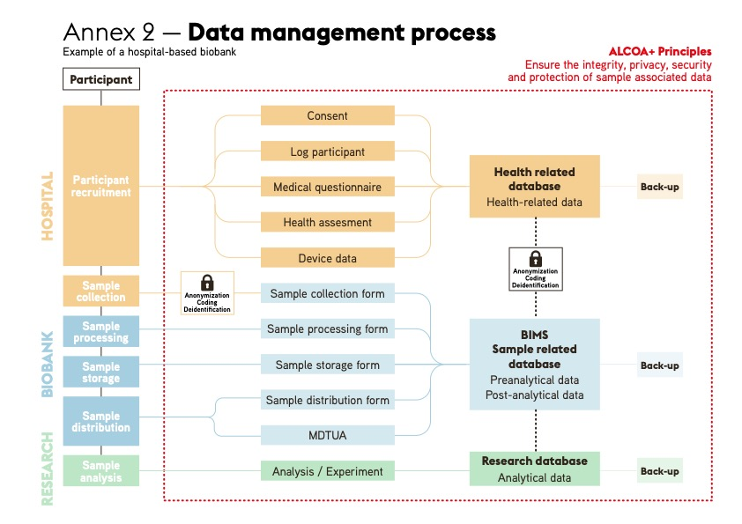

This Annex complements the template proposed by Swiss National Science Foundation to create a Data Management Plan[3].
Storage duration should be documented in the consent documents and in the biobank regulation. Note that for clinical trials, the data should be archived for at least 10 years after the study end.
This list is not exhaustive and should be adapted depending on the biobank strategy and available resources.
Note that the proposed measures are coherent with participant consent, described in the biobank regulation J and in the obtaining consent SOP K.
Note that rules and measures related to data security are often managed by specific IT departments from the institutions. In this case, it is necessary to contact the IT department and learn more about the data security measures applying already to the biobank, and the ones that should be specifically added.
The offices of the personnel using the systems who therefore also have access to the data.
The biobank databases include a full audit trail that is automatically updated and documented. The audit trail should consist of a detailed history of the data as follows: data creation, changes, deletion, who made the changes, and the date and time of the changes.
Note that training on Good Clinical Practices, including basic aspect of data management, are available in some institutions.

